Agenda 1/27/14

Standard:
- 8.G.A. Understand Congruence and similarity using physical models, transparencies, or geometry software.

Essential Questions:
- How can I use Symmetry to describe shapes and properties in a design or problem ?

Activities
- Warm up – Number Sense (5 – 10 min)
- Car activity
- Matching
- Symmetry Inv 1.1

Number Sense
Find 3 numbers that add up to 25.

__ 1. Symmetry | A. A line of symmetry divides a  figure into halves that are mirror images.
__ 2. Reflection Symmetry | B. A figure or design has  reflection symmetry if you can draw a line that divides the figure into halves that are mirror images.
___3. Line of Symmetry | C. A figure or design has rotation  symmetry if it can be rotated less than a full turn about a point to a position in which it looks the  same as the original.
___4. Rotation Symmetry | D. An object or design has symmetry if part of it is repeated to produce a balanced pattern.  In this unit, you learned about three types of symmetry.
___ 5. Translation Symmetry | E. two figures are congruent if you can slide, flip, or turn one figure so that it fits exactly on the other.
___6. Congruence | A design has translation symmetry if you can slide it to a position in which it looks exactly the same as it did in its original  position.
Car Activity
Describe the path the car takes to get to the finish parking space.
1.
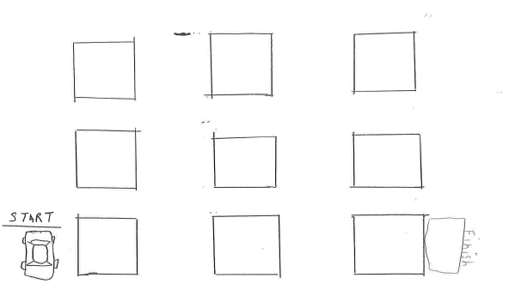

2.
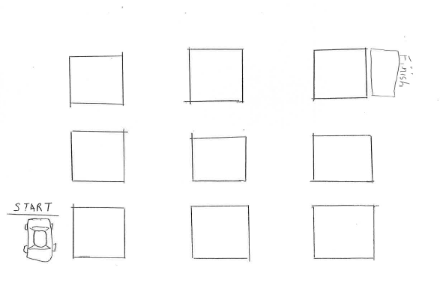

3.
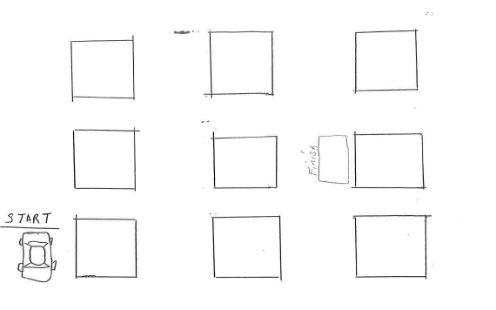

4.
